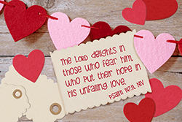

FIRST UNITED METHODIST CHURCH OF FARMINGTON
33112 Grand River Avenue
Farmington, MI 48335


First United Methodist Church of Farmington
10:00 a.m.
February 15, 2026
PRELUDE Yaroslav Daniels
INTROIT “Come and See” Chancel Choir
WORDS OF WELCOME Rev. Bea Fraser-Soots

RESPONSIVE CALL TO WORSHIP Estelle Kalakailo
Come to Christ, the Living Stone, rejected by the world, but in God’s sight chosen and precious.

We have responded to Christ’s call, and seek to be built into a spiritual house, a living reminder of God’s presence on earth.

Once we were no people, but now we are God’s people, called out of the darkness into God’s marvelous light. Therefore, we sing with the Church in all ages:

Blessed by your name, O God, our Redeemer. By your mercy we have been born a new to a living hope through the resurrection of Jesus Christ from the dead.

HYMN “Come, Christians, Join to Sing” UMH #158

RESPONSIVE OPENING PRAYER Estelle Kalakailo
O God, in mystery and silence you are present in our lives, bringing new life out of destruction, hope out of despair, growth out of difficulty.
We thank you that you do not leave us alone, but labor to make us whole.
Help us to perceive your unseen hand in the unfolding of our lives, and to attend to the gentle guidance of your Spirit, that we may know the joy you give your people.
ANTHEM Many Gifts, One Spirit Chancel Choir
by Allen Pote
CHILDREN & YOUTH MOMENT Pastor Bea
SCRIPTURE LESSON: Mark 12:38-44 Estelle Kalakailo
Liturgist: The word of God for the people of God
People: Thanks be to God

HYMN “Lord, You Have Come to the Lakeshore” UMH #344
SERMON Mighty Mites Pastor Bea
OFFERTORY INVITATION Estelle Kalakailo
(We appreciate your continued prayerful and financial support of this community of faith.)
- Please place your tithes and offerings in the collection plate, or in one of our offering boxes. As the ushers come to receive our gifts, please sign the attendance pad, and pass it along to your neighbor.

OFFERTORY PRAYER OF DEDICATION Estelle Kalakailo
OFFERTORY MUSIC Yaroslav Daniels

*SUNG PRAISE Praise God, from Whom All Blessings Flow UMH #94

COMMUNITY PRAYER Pastor Bea
LORD’S PRAYER (In Unison) Pastor Bea
Our Father, who art in heaven, hallowed be thy name. Thy kingdom come; Thy will be done on earth as it is in heaven. Give us this day our daily bread. And forgive us our trespasses, as we forgive those who trespass against us. And lead us not into temptation but deliver us from evil. For thine is the kingdom, and the power, and the glory, forever. Amen.
WAYS TO CONNECT Pastor Bea
HYMN “Whom Shall I Send” UMH #582
SENDING FORTH: You Are A Blessing From God. Now Go Be A Blessing!
BENEDICTION God Be with You Till We Meet Again
POSTLUDE Yaroslav Daniels


2026 Offering Envelopes are out on the table.
2025 Giving Statements have been sent out via email, if you have one.

Did you know: Our finance team and pastor are currently working on a budget and strategic plan for 2026. The budget has everything from office supplies to new doors and our pastor's strategic plan will forecast what we have coming up inside and outside our walls. We hope to have these ready to share by the end of the month. Stay tuned!

Did you know: We had a great training about the Simplified and Accountable Structure last Saturday. Our Administrative Council has voted to develop an exploratory team to discern whether this would be a helpful structure for our church. Are you interested in serving on this team? Let Brian know!

Virtual Rummage Sale Update for 2025

Sales for 2025 totaled 1,701.81. This is down significantly from prior years because I have not had as much time to list items for sale. The economy may also be a factor. As of January, 2026 eBay sales since 2020 (when I started selling items on eBay for the church) sales total $18,358.03 with 719 items sold.

Below is a list of the most interesting items sold in 2025. Were any of them yours?
Kate Spade Owl Watch $65 Faux Turquoise Squash Blossom Necklace $22
LeCreuset 4 qt brown Dutch oven $66 Vtg women's brown suede vest with long fringe $29
Vtg men's Frye Leather loafer shoes $56 Olive green Army tool canvas bag $66
5 Blue & White Currier & Ives drinking glasses $36
Lg Fragonard Blue Oval Courting Couple porcelain platter $33
Women's green leather Ferragamo pumps $68
Nike Air Jordan Martin the Martian High-top shoes $35

No monies were expended from eBay sales in 2025. However, I am currently in discussion with the
Trustees about funding some landscaping work in the courtyard.
Joy Wilson


MEETING ON Monday, March 2nd @ 6:30 P.M.

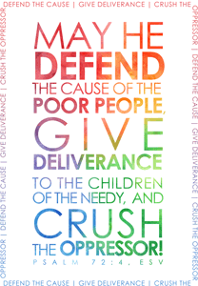

is our
PAY IT FORWARD
choice for February CCMM3005

.

Noah Central grateful for the $352 October contribution.


CARING MINISTRY LIST
STRENGTH & WISDOM DEALING WITH
HEALTH & LIFE CHALLENGES:
Claudette Howell, Maggie Clewley, Pat Dyert, John Hopeck,
Bonnie Kennedy, Paul King, Dean Koppin, Cathy Kwasky,
Scott Lodge, Denise Rogers, Denise Ruff, Oliver Schultz,
Sharon Scott, Bernie Shaw, Darrell Simmons, Bill & Suzanne White, Sandy Welling, Ruth Yuill

The Caring Ministry keeps those who are shut in, hospitalized or sick and unable to attend church connected to the church through visits, cards, and phone calls. "Please notify our office via call or email: office@farmingtonfumc.org or pastor of any requests by Monday to be included in the bulletin and by Thursday for verbal announcements. Names will be removed after 60 days unless otherwise requested."



8th In loving honor of the Aiyesimoju family
14th

DEDICATION OF

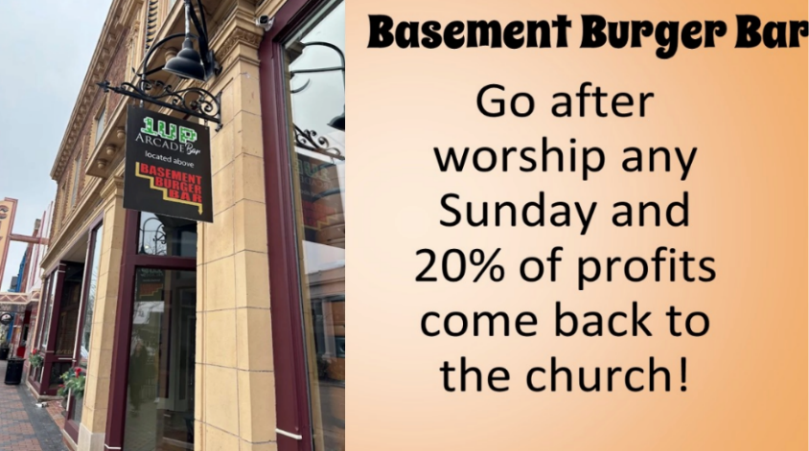



The following committees are
looking for additional members:
Methodist Men, Finance, Outreach,
Trustees, The Streaming Team,
and Website Team.

If you are interested in any of these committees, please contact. Pastor Brian at (269) 274-0029.
Our teller team could use your help. Looking for 3 or 4 more volunteers that are willing to help count the offering after Sunday service. It takes about 30-60 minutes to complete depending on the Sunday. We schedule 2 tellers per Sunday. Commitment would be for no more than 2 Sundays a month depending on the scheduling. There may be a month that you may not be required to count. Scheduling is flexible.

WOULD YOU LIKE TO BE A LITURGIST?
Liturgists are responsible for leading the opening prayer, reading the scripture lesson, leading the offering prayer, and reading the explanation of offering options. If you are interested in joining the liturgist team, please contact Jill Burress at jillb69@aol.com.

“HOW TO LIVESTREAM OUR WORSHIP SERVICE”
You can view our worship services live each Sunday morning, even if you don't have a Facebook page/account. Here is how to connect:

- Go to: www.farmingtonfumc.org/watch or
- Access the church’s Facebook page at: www.facebook.com/farmingtonfumc/
- Once on the church’s Facebook page, select the video marked Live in red.
- You can now view the livestream of our worship service.

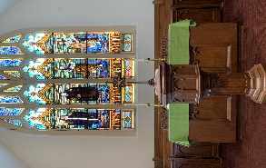
DID YOU MISS THE WORSHIP SERVICE?
You can view all previous worship services and sermons on our YouTube Channel, Facebook Page, or Website:
- Youtube: www.youtube.com/@farmingtonfumc1829/videos
- Facebook: www.facebook.com/farmingtonfumc/videos.
- Website: www.farmingtonfumc.org/watch-live


YOUR FINANCIAL SUPPORT IS APPRECIATED
GIVE TODAY

Thank you for continued prayerful and financial support of the church. If you would like to make a gift to the church, please use one of the following methods:
1) Drop-off or Mail-in your gift to:
First United Methodist Church of Farmington - 33112 Grand River Ave
Farmington, MI 48336
2) Use PayPal, and select: First United Methodist Church of Farmington
3) Scan the QR code and follow the prompts.

FOLLOW US ON INSTAGRAM @farmingtonfumc


FIRST UNITED METHODIST CHURCH OF FARMINGTON
33112 Grand River Avenue † Farmington, MI 48336
News & Notes February 8, 2026
248 474-6573 or 248 474-6595
Church Office Hours
I’m working from home on
Mondays and Fridays
Tuesday - Thursday
11:00 am to 3:30 pm

Pastor Bea
Tuesday-Thursday
10:00 am to 2:00 pm

Pastor Brian
Monday, Wednesday, Thursday 10-3
Please call/text 269-274-0029 to make certain I am available.
Rest & REfreshME happens on Fridays!
Tuesday, February 10th
10:00 a.m. Bible Study
7:00 p.m. Women’s Bible Study
Wednesday, February 11th
10:00 a.m. Caring Ministry
12 noon Anna Circle
7:15 p.m. Boy Scouts
Thursday, February 12th
6:00 p.m. Hand Bell Rehearsal in the bell room
7:00 p.m. Vocal Choir Rehearsal
Friday, February 13th
5:00 p.m. Detroit Baptist Chin
Saturday, February 14th
Sunday, February 15th
10:00 a.m. Worship/SS Coffee Hour follows
11:30 a.m. Bible Study
11:30 a.m. Intro to Bells Class
12 noon Classical Indian Dance

SUBMISSION DEADLINES:
Announcements/information to be shared in the order of worship/weekly News & Notes, please email your information to Phyllis Anderson (phyllisa@farmingtonfumc.org) no later than 11:00 a.m. on Monday mornings.

ANNA COOK CIRCLE FELLOWSHIP
February 11, 2026 @ 12 noon
BRING YOUR SANDWICH & BEVERAGE

LYDIA CIRCLE FELLOWSHIP Friday, Feb 20th ^{t}


Fat Tuesday Dinner 17th @ 6:00 p.m.
Ash Wednesday 18th @
Franklin Community UMC
Thursday Nights Together
Lenten Bible Study
Dinner 5:30 p.m. Study 6:30 p.m. February 26th – March 26th

CRAFTER’S FELLOWSHIP
3rd Saturday’s of the month
February 21, 2026
9:30 a.m. – 2:00 p.m.
Bring a project to work on and a sandwich and see what we are creating.

Susan Cook, Coordinator






FELLOWSHIP
Saturday, February 21st 5 p.m. – 8 p.m.

7 Jill Burress, 8 James Totten,
11 Gary Shier, 13 Phyllis Paske
15 Mike Mohr, 18 Carol Riley,
20 James Paske, 21 Bernie Shaw
23 Carolyn Wik, 28 Ed Eidt

11 Ken & Amy Berry

.

